**Addressing & Byte Ordering**

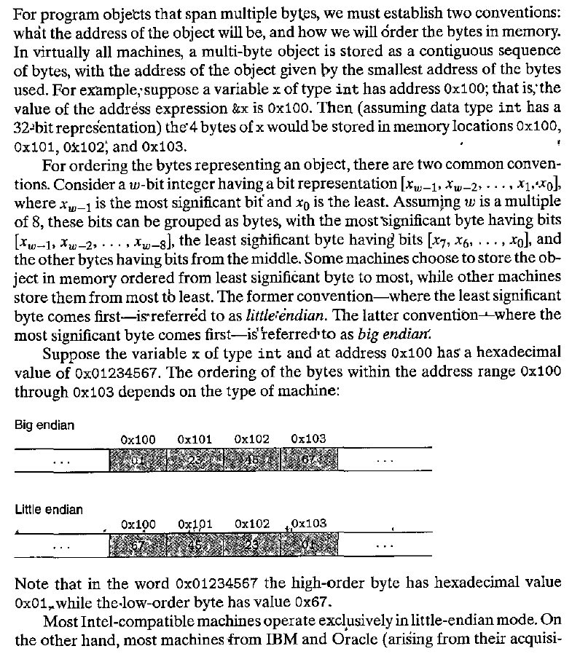

**Question#1**

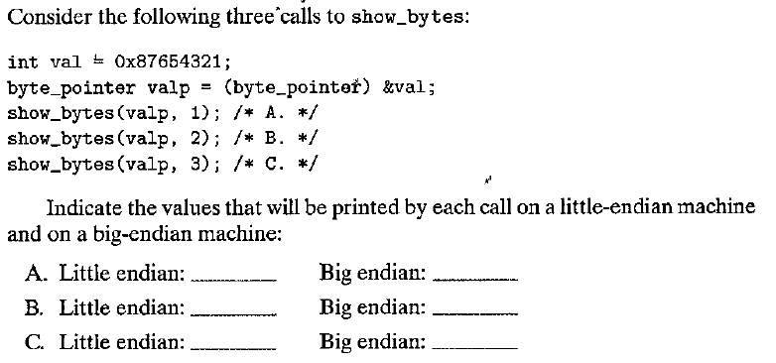

**Representing Strings**

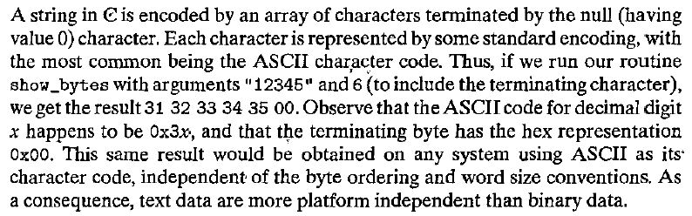

**Question#2**

